**Lab Report 3**

**Aayushi Mehta AU2020057**

**Introduction**

The impact of visual attention on tasks requiring target recognition among distractions is demonstrated known as as visual search. According to research from psychophysics, the capacity to distinguish between the target and the distractor influences search task performance to a great extent. By boosting the reaction to the attended stimulus and limiting the range and quantity of units reacting to the distractions, attention has an effect. Both techniques enhance performance by making the attended signal more discriminable. Visual search is the term used to describe the process of identifying a target among distractions. A single focus often stands out from the distractions alon a lot of angles.The processes involved in sensory, perceptual, and cognitive aspects of visual search can all be altered by manipulating the search task. By restricting and choosing from all the information accessible at different stages of processing, attention modifies visual search in turn. Particularly, the impacts of set size (the amount of stimuli in a display) and the impacts of cueing subsets of stimuli within the display highlight the impact of divided attention and selective attention, respectively.

**Procedure**

**Results**

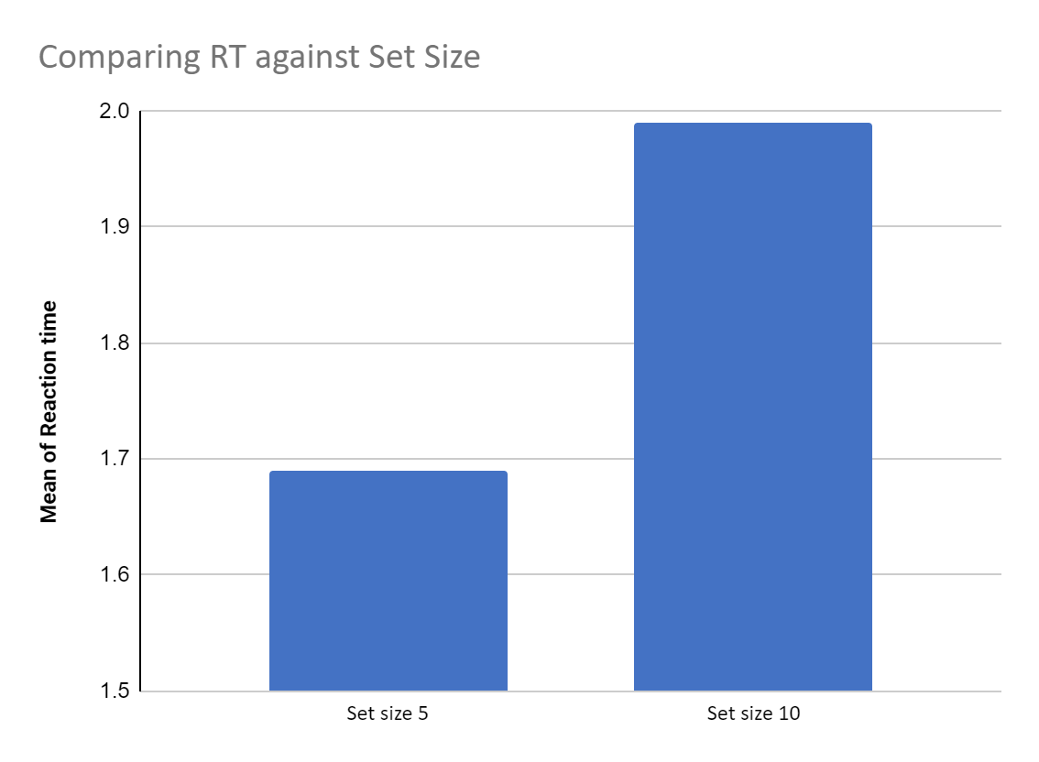

|  | Reaction time mean |
| --- | --- |
| Set size 5 | 1.69 |
| Set size 10 | 1.99 |

| Slope : |  |
| --- | --- |
| x2 | 10 |
| x1 | 5 |
| y2 | 1.99 |
| y1 | 1.69 |
| y2 - y1/ x2 - x1 | -16.66666667 |
| Slope = | -16.66 |

**Discussion :**

As observed from the data and graph showing reaction time taken when the numbere of distractions were 5 , the time taken to react was comparatively lesser then when there were 10 distractions. The slope helps measure the rate at which target is processed in a visual search. By evaluating the slope of reaction time over the quantity of distractions, it is also feasible to quantify the function of attention in visual search studies. The slope often rises as reaction times rise when high levels of attention are needed to look at a complex array of stimuli (conjunction search). The slope lowers for straightforward visual search tasks (feature search) since these activities need quick reactions and little concentration. However, as non-attentional variables can also influence response time slope, the use of a reaction time slope to gauge attention is debatable.